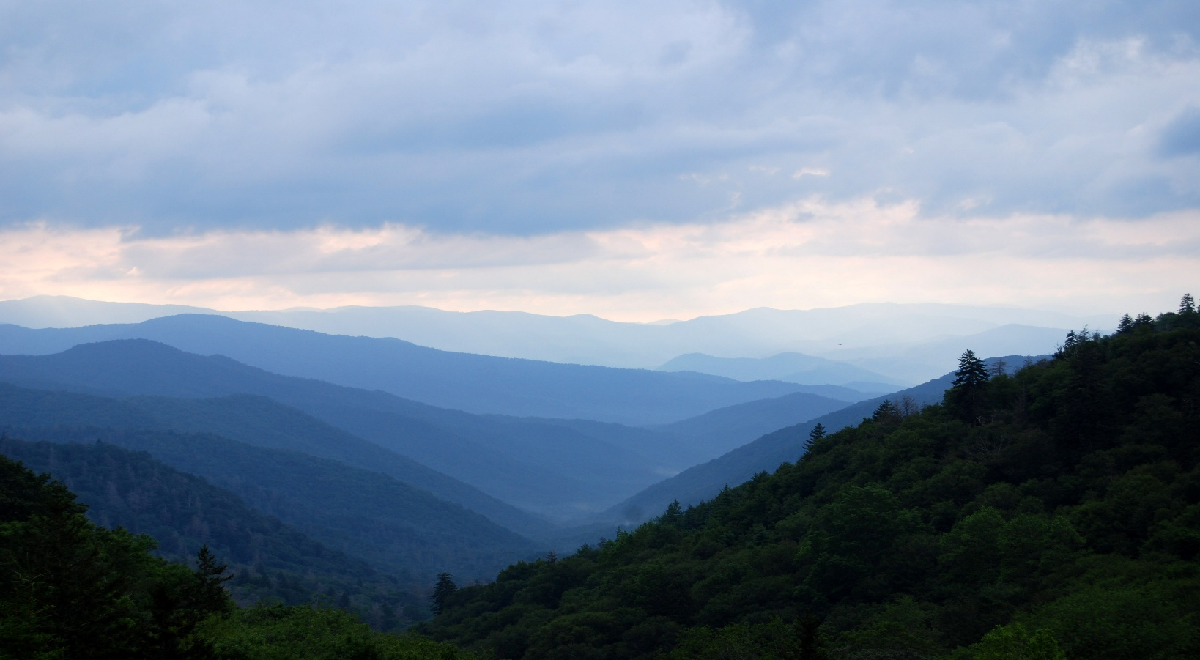

Creatively Changing

**An Artful and Spiritual Retreat for Personal Transformation**

**in the Stunning Smoky Mountains of Tennessee**

October 5-9, 2025

Limited to 12 participants

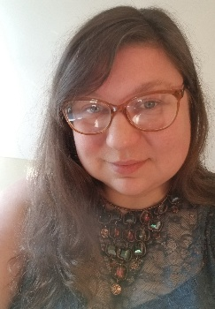

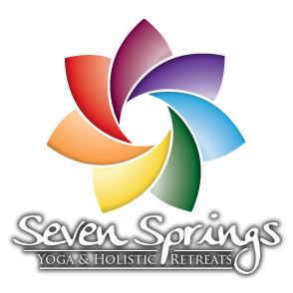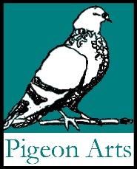

Facilitated by: Jesse White

Director and Spiritual Arts Doula

Pigeon Arts

**Are you preparing to make an important change in your life?**

**Would you enjoy a creative and meaningful community in which to cross that important threshold of change?**

**Join us for this Transformative Arts Retreat in Tennessee!**

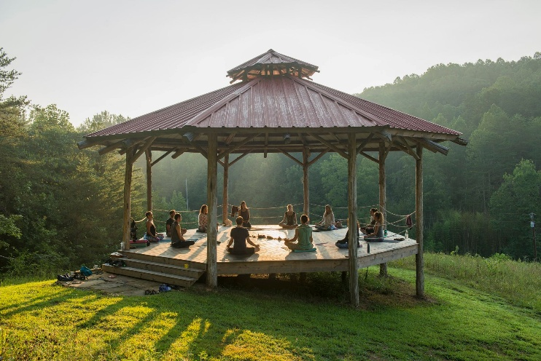**Within the sanctuary of Seven Springs Retreat Center and our creative community, we will journey together to make an important change in our lives. Together we will identify the individual thresholds the Sacred asks us to cross at this time.** **Through guided visualizations, journaling, collaging, drawing, and painting experiences we will:**

* **Release** that which no longer serves us.
* Experience a sacred **Cacao Ceremony** and sit with unknowns and mystery.
* Identify and **change the narratives** we tell about ourselves.
* **Practice mindfulness** of **synchronicities** and every-day **mysticism.**
* Explore Joseph Campbell’s **Heroic Journey/Wheel** and envision ourselves making an important change.
* Plan **a meaningful and sacred personal transformation ceremony.**
* Enjoy a **Yoga Class.**
* Invite the Sacred to collaborate with us through **creative prayer.**
* Walk the **Labyrinth** with intention.
* **Cross the threshold of Transformation.**
* **Celebrate** ourselves and our community.
* Begin the process of **incorporating deep lessons** into our lives.

**Following the program, all participants may schedule one follow-up, online, creative and spiritual Transitional Life Coaching session through** [**Pigeon Arts**](https://pigeon-arts.org) **for a discounted retreatant fee.**

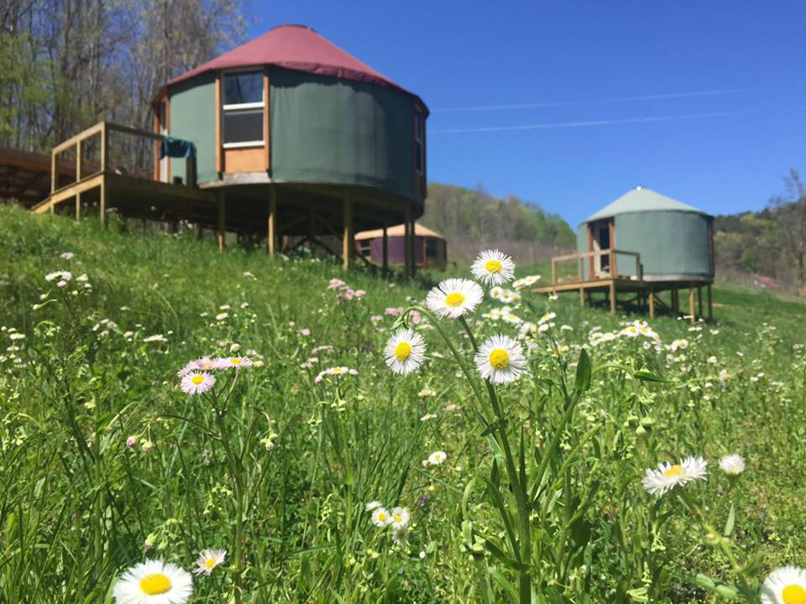

**Accommodations: Yurts!**

Seven Springs Retreat Center has private and shared accommodations in yurts with décor from indigenous peoples around the world. Complete with heat and bed warmers, these yurts provide a uniquely rich place to rest between program sessions.

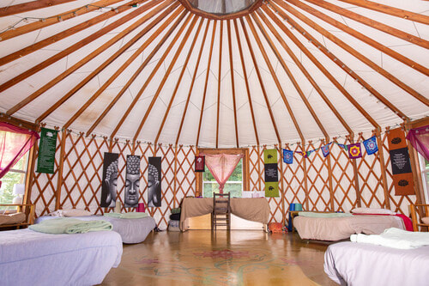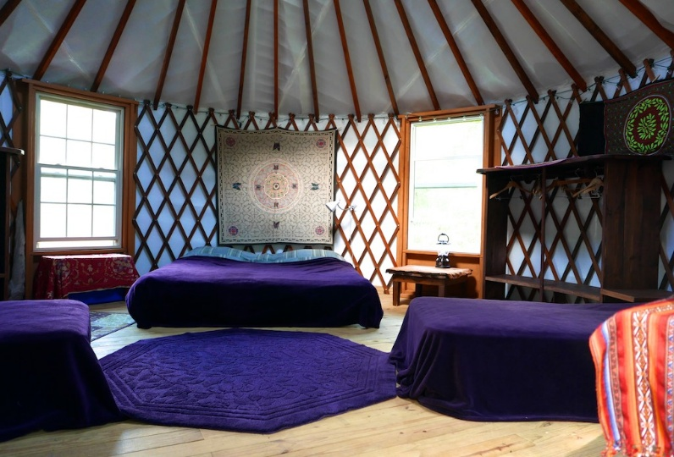

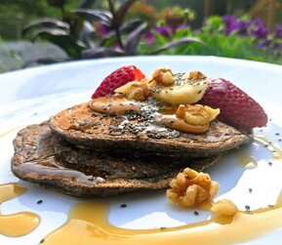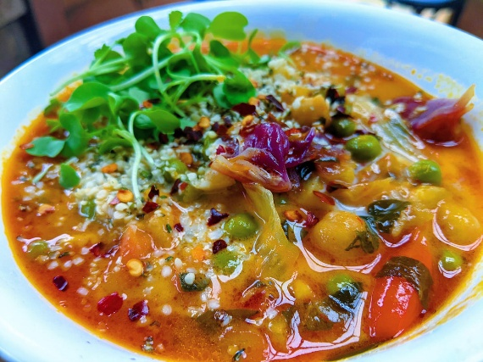**Meals!**

**Fresh from the Farm**

**Organic**

**Vegetarian Meals**

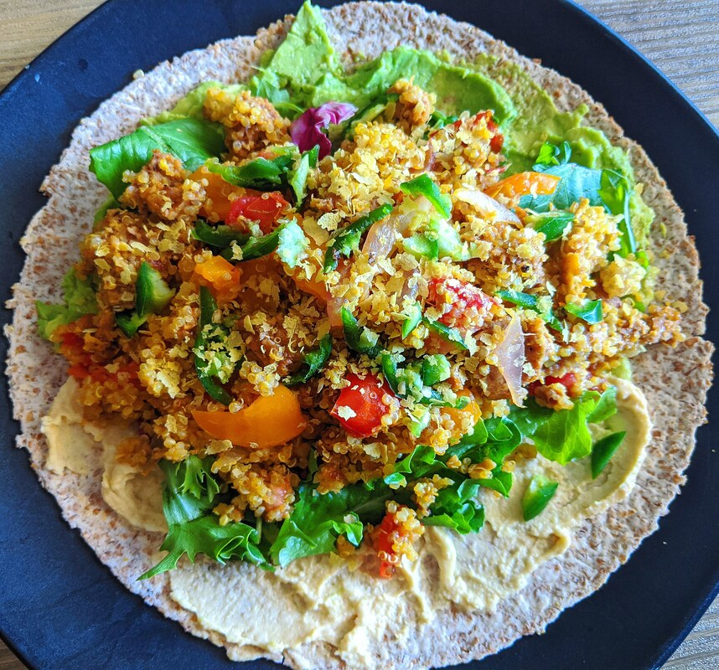**Seven Springs Retreat Center shares this about the Cuisine:**

We understand that we are what we eat, literally. We value providing organic, clean and local foods that nourish our bodies, minds and spirits. At Seven Springs you will enjoy three meals a day, lovingly prepared, with plenty of nutrients and proteins. Examples of meals may be a breakfast of organic oatmeal or pancakes with fruit, nuts, seeds, and sweet toppings of your choice; a lunch of build your own burritos with all the fixings, and a dinner of a nourishing soup or coconut cashew curry with rice and salad.

We also provide teas made with our homegrown herbs, as well as organic, fair trade coffee.  
  
You are always welcome to bring snacks if you like. We ask that the snacks be kept in a special place in our kitchen and no food eaten in the yurts. If you enjoy animal proteins, we suggest bringing jerky or bone broth. We ask that you do not bring meat that needs to be cooked. The food we provide is well balanced with various protein sources to keep you full and energized throughout your stay!  
  
**Please let us know if you have any dietary restrictions and we will do our best to accommodate.**

**About Jesse White, Facilitator:**

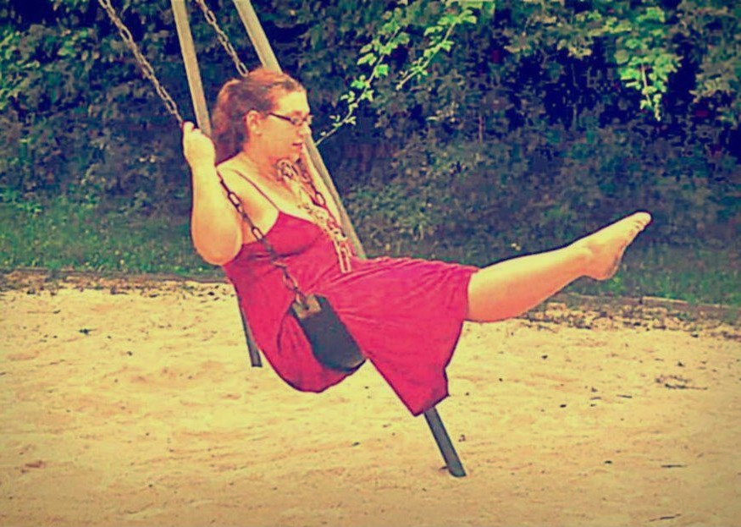**Jesse White is a narrative expressionist artist and writer.  She serves as Director and Spiritual Arts Doula for Pigeon Arts.  She assists clients privately and in groups to make important changes in their lives, and she facilitates transformative and creative retreats across the country.  Jesse holds degrees and certificates in Psychology, Creative and Spiritual Process, Transitional Life Coaching, and Business.**

**She is the author of Pendle Hill Pamphlet #468,**[***God’s Invitation to Creative Play***](https://pendlehill.org/product/gods-invitation-to-creative-play/)**.  Her artwork has been exhibited throughout Pennsylvania and North Carolina, in Los Angeles, CA, in London, England, and in Medellín, Columbia.**

**A long-time teaching artist, Jesse has also has a work history in expressive arts therapy, and in creating art for social change.**

**Jesse served as the Arts & Spirituality Coordinator for Pendle Hill Retreat Center (PA) from 2013-2020 and as Clerk of the Board of the**[**Fellowship of Quakers in the Arts**](http://fqaquaker.org/)**from 2021-2023.  She currently serves as Clerk of Frankford Executive Meeting (PA).**

**Your Investment:**

Includes program fees, room and board. (These fees do not include airfare, other transportation, or extras options noted below.)

Most accommodations are shared with 2-4 participants per yurt.

**Early bird pricing and standard pricing**

**Total program, shared accommodations, and vegetarian meals:**

**$1680 before July 1**

**$1800 between July 1 and September 1.**

There are 1-2 private yurts available with one Queen sized bed. If you are interested in this accommodation as a single participant:

**$1980 before July 1**

**$2200 between July 1 and September 1.**

If you are your partner are coming together and wish to stay in this private space, the fee per couple is:

**$3660 before July 1**

**$3880 between July 1 and September 1.**

First come, first served, once total fees are paid.

Beds come in various sizes. These are offered first come first served, once all fees are paid.

**Payment plans are available!**

If you are coming as a small group or with a friend, please indicate with whom you’d prefer to share a yurt and I will try to accommodate that.

Please plan to arrive to Seven Springs between 3-6:45pm. If you would like to join us for dinner, please plan to arrive by 5:45pm. Our first session begins promptly at 7:15pm on Monday.

**Extra options include:**

* 1 hr Reiki session $115
* 1 hr Massage / 1.5 hr massage $115 / $165
* One Private 1.5 hr Follow-up Zoom session with Jesse with a retreatant discount! ~~$250~~ $150

**FINAL DEADLINE TO REGISTER IS SEPTMEBER 1, 2025**

**What to Bring:**

* journal and some favorite pens
* set of watercolors (your choice)
* at least three watercolor brushes of varying shapes and sizes
* small reusable watercolor palette
* Layers! Temperatures can be unpredictable in the mountains. Please bring comfortable clothes, including light long sleeves and long pants.
* light hiking shoes and sandals
* sun hat
* flashlight or headlamp and extra batteries
* all natural personal products (natural toothpaste, shampoo, etc.)
* natural bug spray and sunscreen
* water bottle
* ​yoga mat (if you prefer your own)
* Ear plugs (optional)
* musical instruments (optional)
* openness, kindness, curiosity, authenticity

All other creative supplies and yoga items are included in your program fees.

**Click HERE.**

**Ready to Register?**

**Questions?** Please email Jesse White at [SpiritualArtsDoula@gmail.com.](mailto:SpiritualArtsDoula@gmail.com.)